Scripts for Scene: **WT_Corner1**

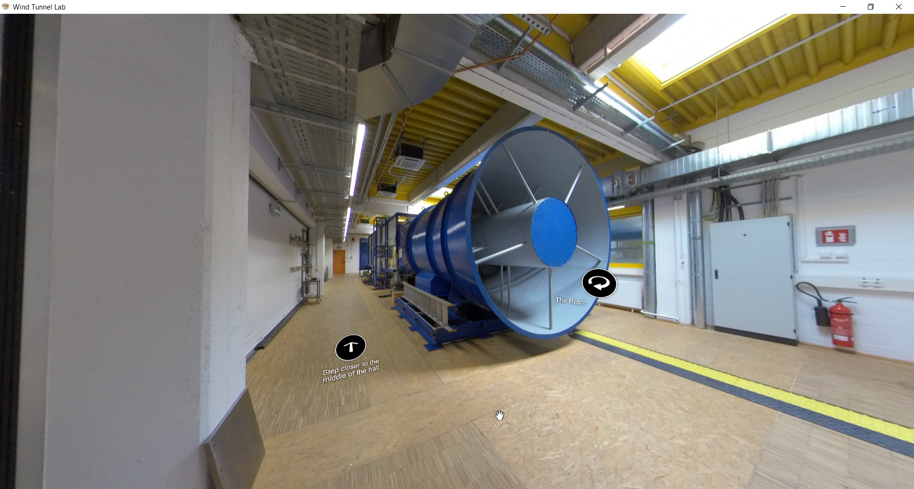

**If the current hostport is not mentioned to be “deleted” then the hotspot should not be deleted.**

|  |  |  |
| --- | --- | --- |
| Nr | Hotspot (see red arrow) | Script |
| 1 | Hotspot: General description of the wind tunnel | Slide Figures/Album (with text):  Slide-1 Figure:    Slide-1 Text:  The WISt Boundary Layer Wind Tunnel Laboratory Ruhr-Universität Bochum has length of 9.4 m. The cross-section of the chamber or the test room is 1.6 m (height) x 1.8 m (wide). The maximum wind speed which can be performed is about 30 m/s which corresponded to a volumetric flow rate 86 m3/s. The wind tunnel can perform both 2-D test condition and the atmospheric boundary layer of incoming wind profile. To obtain the atmospheric boundary layer profile, the wind tunnel has castellated barrier at the beginning, Counihan Vortex/Turbulence Generator and the floor/ground roughness. Turn table made of wood plate, where a 3-D scaled model is placed on top of it, can be freely turned to “adjust” the incoming wind direction. |
| 2 | Hotspot: Short 2D Video (ca. 45 Sec)  “Feel the wind tunnel!” | File: FeelTheWindTunnel.mp4  Label: “Feel the wind tunnel!” |
| 3 | Hotspot: Short 2D Video  “Round walk around the wind tunnel!” | File: walkabout.mp4  Label: “Round walk around the wind tunnel!” |